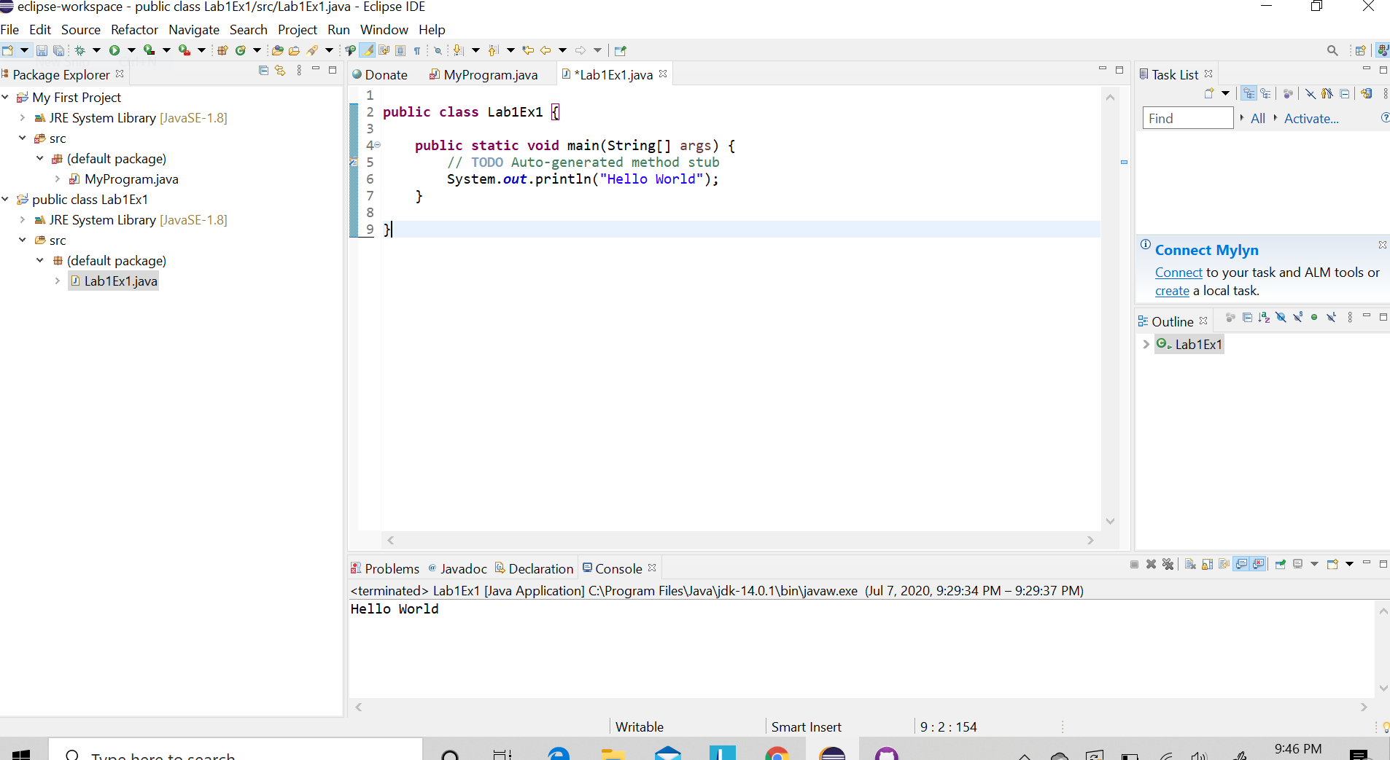Exercise 1

Predictions

1. Will not run due to the file name is being changed.
2. Will not produce the Hello World as a result of removing the first quotations mark.
3. Semicolon will cause it to not be complete causing it to not run.
4. Removing the last brace will not work due to it is not closed off saying that you are finished. Similar to using a math equation in excel.

Reality

1. The program did not run when changing Lab1Ex1 to Hello
2. The program did not run due to the following options.
3. Wouldn’t run due to a syntax error.
4. Another syntax error missing “}”

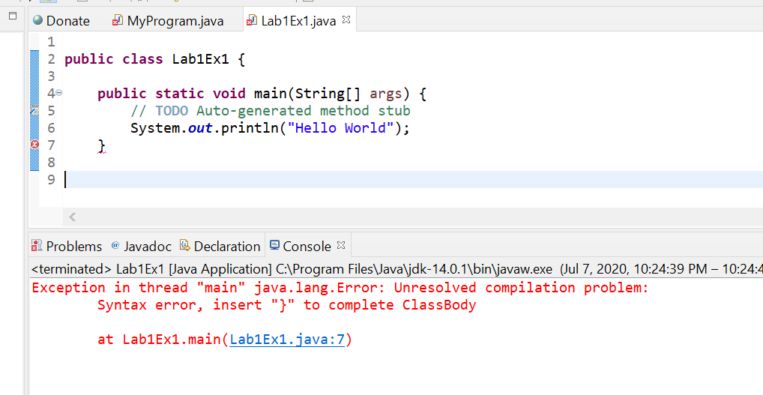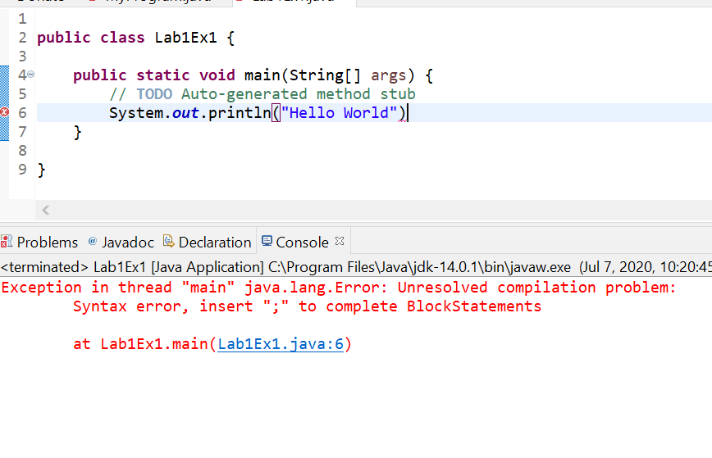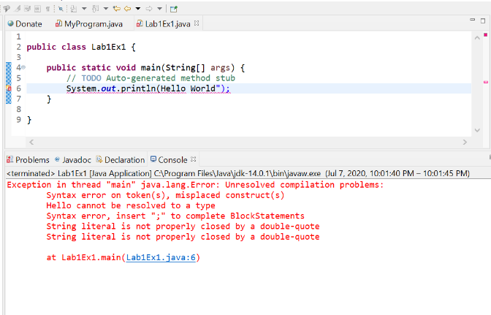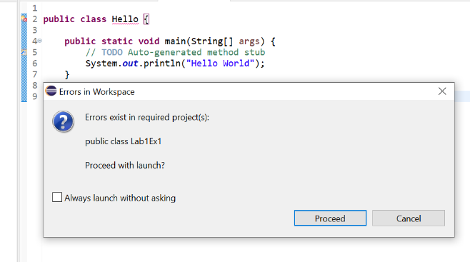

**D**

**C**

**B**

A